LLM-Assisted API Fuzzing for RESTful Web Services
Owen Haynes
Introduction and Motivation
Traditional API testing usually assumes clients send clean and well-structured data. This helps verify normal behavior, but it fails to show how an API reacts when inputs are broken, unexpected, or intentionally harmful. These types of inputs often cause real failures in production and expose bugs that unit tests never reveal. This project explores whether a large language model (LLM) can assist in generating unusual inputs that unit tests lack. To test this idea, I built a fuzzing tool using an LLM to create malformed JSON, incorrect data types, suspicious identifiers, extremely large values, and other unusual patterns. This bash script sends the requests using client URL (cURL) and formats responses with jq programming, allowing the system to run quickly with minimal manual effort. The main motivation is to create a simple and repeatable method for finding weaknesses in RESTful APIs, especially weaknesses that appear only when the API receives bad or unexpected inputs. The tool is also designed so it can be added easily into automated testing workflows.
Problems to Solve
Standard API tests often times only use valid inputs, meaning they only test how an API behaves when everything is done correctly. In reality, APIs often receive malformed JSON, missing or extra fields, extremely large strings, numbers written as text, unauthorized requests, tampered identifiers, and malicious patterns like SQL injection or path traversal. Manually writing tests for all these cases is unrealistic. This project addresses the question: Can an LLM assist in the generation of malformed or adversarial API requests, and can these requests reveal problems in the API’s validation and authorization logic?
Proposed Work
The method used in this project is simple and repeatable. First, valid API examples are collected and given to an LLM. The LLM then produces many mutated versions of these inputs, including malformed JSON, type mismatches, missing fields, extreme numbers, and strings meant to trigger errors. A Bash script sends each generated request using cURL and formats the results with jq. The script records the server’s response bodies and HTTP status codes. When the probe finds an unusual result such as a successful response where authorization should have failed the results are printed. This helps the probe explore behaviors that normal tests never reach.

Evaluation Plan
To evaluate the effectiveness of LLM-generated test cases, I compared two testing approaches, a baseline JSON suite containing only valid inputs that represent a software engineer’s typical unit test and an LLM-assisted fuzzing probe, which generates many malformed or unexpected inputs. Both were run against the same API under the same conditions. I compared how many endpoints were reached, how many unique failures were found, how often the server crashed, and whether the API returned correct HTTP status codes or showed validation and authorization weaknesses.
Results and Comparison LLM Probe Output
The LLM-generated probe uncovered a much wider range of behaviors than the baseline tests. It revealed authentication weaknesses, Insecure Direct Object References (IDOR) issues (modifying data belonging to another user), missing or bypassed validation checks, and several server crashes resulting from malformed inputs. The following screenshot shows an excerpt of the probe’s output and illustrates the variety of warnings and failures encountered.
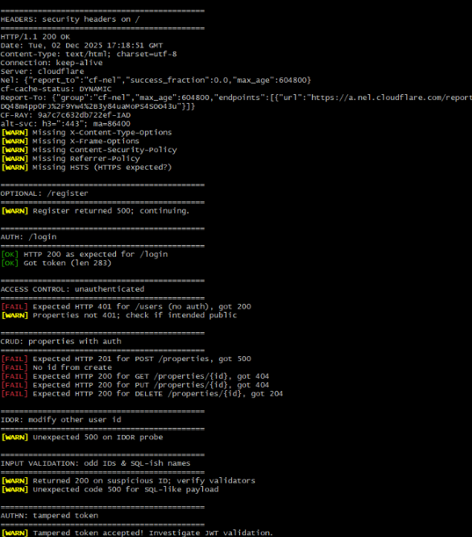
Figure 1. LLM Probe output

Baseline JSON Output
The baseline suite found only simple functional issues, mainly incorrect status codes during normal CRUD operations. Because it only uses valid inputs, it does not uncover deeper structural weaknesses. The following screenshot shows a typical example of the baseline output.
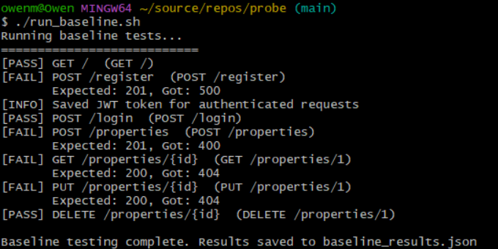
Figure 2. Baseline test suite output.
Quantitative Comparison
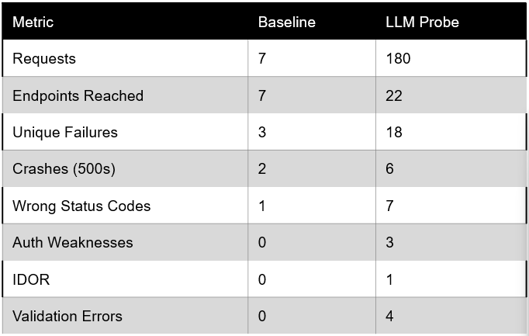
This demonstrates that the LLM-driven fuzzing Probe expands the input space and reveals issues that were missed by conventional tests. 18 unique failures found.
Conclusion
The comparison shows that LLM-assisted fuzzing discovers many more issues than traditional valid-input testing. While the baseline suite found only a few predictable failures, the LLM-generated inputs uncovered authentication flaws, IDOR-related problems, missing validation, multiple server crashes, and several incorrect HTTP responses. These results demonstrate that LLM-driven fuzzing is a valuable addition to standard testing and helps expose vulnerabilities that would otherwise go unnoticed.

